Linux Commands

Name:Nisarga Kunder

System and hardware information

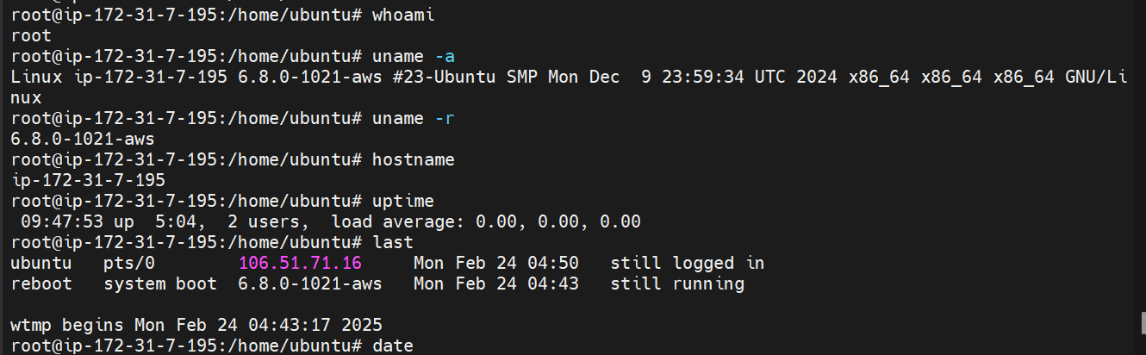

File and Directory commands:

Creating directory-mkdir

To open text file- nano or vim oe gedit filename

To display content in the text files:

Copying Text file:

Copying directories:

Moving,Deleting directories:

Piping And I/O redirection

Sorting:

WildCard chars:

Package Management:

Updgarde:

Update:

Services And Process Management:

Process Management:



User Management And Permissions:

Adding Users:

Added Users:

Deleting Users:

Groups:

Adding to group:

Switching to new user

Changing file permissions:

Granting access to different user in different group from root

Give permission from root nissy to neha profile

Changing file read ,write ,execute access

